Keep the Darby a Reality… Not a Memory

1000 Friends of Central Ohio Annual Meeting
Wednesday, October 19, 2005
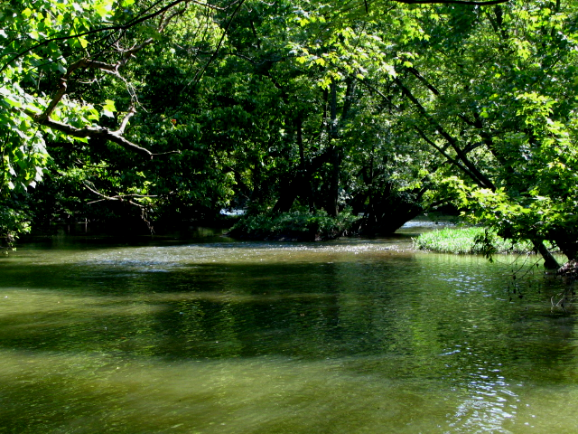
Darby House at Darby Dan Farm
5:30 – Cash bar
6:30 - Outdoor Barbeque
(Enjoyed indoors)
7:15 –Presentations by a Panel of
Special Guest Speakers!
Including Scott Corbett from Senator Mike DeWine’s Office

$25 for Members - $35 for Guests
(Free 15 month membership for guests)
Make your Reservations by October 11
RSVP:1000friendsohio@columbus.rr.com
Call 1000 Friends with questions
614-507-6550
Visit us at www.1000friendsofcentralohio.org

Visit Darby House at www.darbyhouse.com

